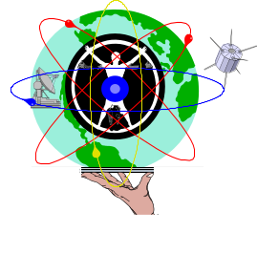 | CHEMISTRY  STAGE 3  2012

Name: ____________________________________________________________________________________________

Teacher: Circle

Mr Lucarelli Mr Lyle Mr Sander Ms K Smith Mr D Smith

TIME ALLOWED FOR THIS PAPER

Reading time before commencing work: Ten minutes
Working time for the paper: Three hours

MATERIALS REQUIRED/RECOMMENDED FOR THIS PAPER

To be provided by the supervisor:
- This Question/Answer Booklet
- Multiple Choice Answer Sheet
- Data sheet

To be provided by the candidate:
- Standard items: Pens, pencils, eraser or correction fluid, ruler, highlighter.

- Special items: Calculators satisfying the conditions set by the School Curriculum and Standards Authority for this subject.

IMPORTANT NOTE TO CANDIDATES

- No other items may be taken into the examination room. It is your responsibility to ensure that you do not have any unauthorised notes or other items of a non-personal nature in the examination room. If you have any unauthorised material with you, hand it to the supervisor before reading any further.

Structure of this paper

Section | Number of questions available | Number of questions to be answered | Suggested working time  (minutes) | Marks available | Percentage of exam
Section One:  Multiple-choice | 25 | 25 | 50 | /50 | /25
Section Two:  Short answer | 11 | 11 | 60 | /70 | /35
Section Three:  Extended answer | 7 | 7 | 70 | /80 | /40
 |  |  |  |  | /100

Instructions to candidates

1. Answer the questions according to the following instructions.

Section One: Answer all questions on the separate Multiple-choice Answer Sheet provided.
Place a cross (X) on each correct answer.
Marks will not be deducted for incorrect answers.
No marks will be given if more than one answer is completed for any question.

Sections Two and Three: Write answers in this Question/Answer Booklet in blue or black pen.

2. When calculating numerical answers, show your working or reasoning clearly unless instructed otherwise. Final answers to calculations should be expressed to three (3) significant figures and include appropriate units.

3. You must be careful to confine your responses to the specific questions asked and to follow any instructions that are specific to a particular question.

4. Spare pages are included at the end of this booklet. They can be used for planning your responses and/or as additional space if required to continue an answer.
  - Planning: If you use the spare pages for planning, indicate this clearly at the top of the page.
  - Continuing an answer: If you need to use the space to continue an answer, indicate in the original answer space where the answer is continued, i.e. give the page number. Fill in the number of the question(s) that you are continuing to answer at the top of the page.
Section One: Multiple-choice 25% (50 Marks)
This section has 25 questions. Answer all questions on the separate Multiple-choice Answer Sheet provided. For each question shade the box to indicate your answer. Use only a blue or black pen to shade the boxes. If you make a mistake, place a cross through that square, do not erase or use correction fluid, and shade your new answer. Marks will not be deducted for incorrect answers. No marks will be given if more than one answer is completed for any question.
Suggested working time: 50 minutes.

- Consider the ion 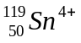

Which of the following shows the number of protons, neutrons and electrons for this ion?

 | Protons | Neutrons | Electrons
(a) | 119 | 49 | 49
(b) | 50 | 69 | 49
(c) | 119 | 69 | 52
(d) | 50 | 69 | 46

- What is the formula of an ionic compound consisting of positive ions with an electron configuration 2, 8, 8 and negative ions with the same configuration?
(a) LiF
(b) MgS
(c) NaF
(d) KCℓ

Questions 3 and 4 refer to electron configurations for elements I, II, III, and IV shown below.

I 2, 1
II 2, 3
III 2, 8, 1
IV 2, 8, 4

- Which of these elements belong to the same group of the periodic table?
(a) I and II only
(b) I and III only
(c) I, II and III only
(d) II and III only

- Which of these elements will have the lowest first ionisation energy?
(a) I
(b) II
(c) III
(d) IV

- Soap can be thought to be represented by the general formula RCOONa. In aqueous solution soap dissociates as shown here.

RCOONa(s)  RCOO⁻(aq) + Na⁺(aq)
Soap

Which of the following statements can account for the cleaning action of soap?
(a) The R group of the RCOO⁻ ion can dissolve both polar and non-polar substances.
(b) The COO⁻ part of the soap ion dissolves in water while the R group dissolves in
non-polar substances.
(c) The sodium ion is responsible for dissolving polar substances while the RCOO⁻ ion dissolves non-polar substances.
(d) The RCOO⁻ part of the soap is said to be hydrophobic while the Na⁺ is hydrophilic.

- Which of the following statements concerning intermolecular forces is/are correct?

I All molecules that contain polar bonds are polar molecules.
II Hydrogen bonding only occurs for molecules containing O-H bonds.
(a) I only
(b) II only
(c) both I and II
(d) neither statement is correct

- Why is the bond between a sulfur atom and an oxygen atom polar?
(a) The O atom is more electronegative than the S atom.
(b) The S atom has a higher positive charge in the nucleus than the O atom.
(c) The S atom is smaller than the O atom.
(d) The S atom has more electrons than the O atom, so it will be negative relative to the O atom.

- Which of the following molecules is polar?
(a) | CH₄
(b) | CBr₄
(c) | 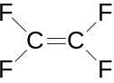
(d) | CH₂Br₂

- Consider the statements about the following reaction:

2H₂O₂(l) → 2H₂O(l) + O₂(g)

I H₂O₂ is reduced.
II H₂O₂ is oxidised.
III H₂O₂ acts as a reducing agent.
IV This is not a redox reaction.

Which of the above statements is/are true?

(a) IV only
(b) II and III only
(c) I only
(d) I, II and III only

- Which of the following statements regarding standard reduction potentials, Eº is/are correct?
I The Eº values change slightly with concentration changes.
II Half reactions with negative Eº values only occur in the reverse direction.
III Doubling the coefficients of a reduction half equation doubles the Eº.

(a) I only
(b) II only
(c) III only
(d) I and II only

Questions 11, 12 and 13 refer to the following graph, which shows the trend of first
ionisation energies for the first 20 elements.

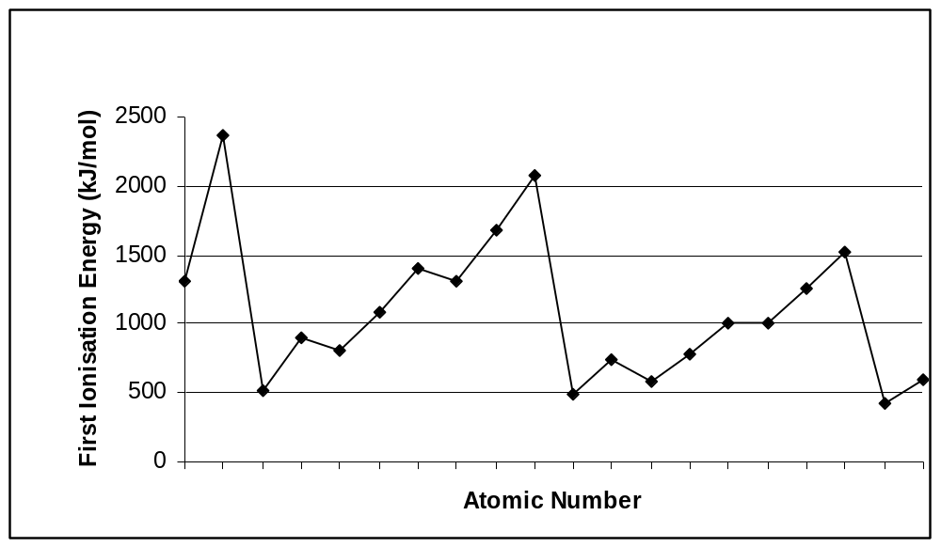
A
B
C
D
E
F
G
H
I
J
K

- Which of the following statements best explains the trend in first ionisation energies for the elements labelled A through to H?
(a) There is an increasing number of electrons in the atoms going from element A to element H.
(b) The atomic radii increase from element A to element H.
(c) There is an increasing number of protons in the nuclei going from element A to element H.
(d) Electrons are being added to progressively higher shells for elements A to H.

- Which of the following combinations of atoms is most likely to result in a covalent molecular compound?
(a) B with F
(b) F with K
(c) C with J
(d) B with C

- Complete the statement about this graph.
This graph shows that moving down group 1 and 2 the ionisation energies .........
(a) decrease a great deal.
(b) decrease slightly.
(c) increase a great deal.
(d) increase slightly.

- The second ionisation energy for all elements is higher than the first ionisation energy. Which of the following statements gives the best basis for explaining this?
(a) The second electron is in a higher numbered shell.
(b) The net positive charge is greater.
(c) The nuclear charge increases .
(d) Both (a) and (b).

Questions 15 and 16 relate the following information:

The overall redox reaction occurring in a dry cell (Leclanché cell) is shown below.

Zn(s) + 2NH₄⁺(aq) + 2MnO₂(s) → Zn²⁺(aq) + Mn₂O₃(s) + H₂O(l) + 2NH₃(aq)

- Which of the following statements regarding the dry cell are correct?
I The zinc is acting as the anode.
II The oxidation state of manganese drops from +4 to +3.
III Ammonium ions act as an acid in this the cell.
(a) I and III only
(b) I and II only
(c) II and III only
(d) I, II and III

- Which of the following will not increase the rate of the redox reaction?
(a) Increasing the concentration of ammonium ions.
(b) Grinding up the MnO₂ into a finer powder.
(c) Using a thicker zinc outer casing.
(d) Warming up the cell.

Questions 17, 18 and 19 relate the following information:

A student was asked to determine the concentration of a solution of ethanoic acid that had a concentration of approximately 4.00 x 10⁻¹ mol L⁻¹. He pipetted 20.0 mL of a 0.500 mol L⁻¹ solution of sodium hydroxide into a conical flask and titrated the ethanoic acid against this sodium hydroxide solution, using phenolphthalein as the indicator.

- What would be the pH of the solution in the conical flask at the start of the titration?
(a) 13.7
(b) 7.0
(c) 14.0
(d) 12.7

- If the ethanoic acid was added until it was slightly in excess, which of the following pH graphs would show the variation of pH during the titration?

(a) (b)
7
14
Volume of acid added
7
14
Volume of acid added
7
14
Volume of acid added
7
14
Volume of acid added
1
1
1
1

(c) (d)

- What approximate volume of ethanoic acid would she expect to have added at the end point of the titration?
(a) 20 mL
(b) 30 mL
(c) 25 mL
(d) 35 mL

- The conjugate base of the acid HCrO₄⁻ is:
(a) H₂CrO₄
(b) H₂CrO₄⁻
(c) CrO₄²⁻
(d) CrO₄⁻

- Which of the following molecules is not an isomer of the others?
(a) 2-methyl-3-hexene
(b) 1,3-dimethylcyclopentane
(c) 2,3-dimethyl-1-pentene
(d) 3-ethylpentane

- Which of the pairs of compounds below could be used to synthesise the following molecule?
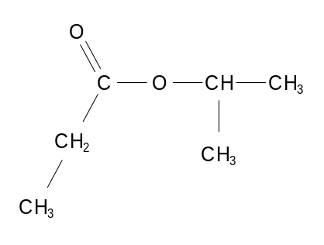

(a) propanoic acid and propan-2-ol
(b) propanoic acid and 2-methylpropanol
(c) ethanoic acid and propan-2-ol
(d) ethanoic acid and propan-1-ol

- What is the concentration, in ppm of a solution of 1.00 x 10⁻³ mol L⁻¹ NaCl(aq)?
[M(NaCl) = 58.44 g mol⁻¹ and assume that 1 L of solution has a mass of 1 kg]
(a) 5.84 x 10⁻² ppm
(b) 58.4 ppm
(c) 5.84 x 10⁴ ppm
(d) 0.171 ppm

Questions 24 to 25 refer to the following electrochemical cell operating at standard conditions.

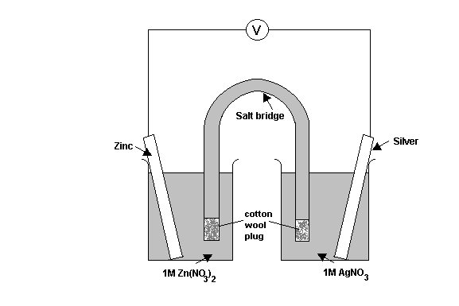
- Which of the following reactions will occur in this electrochemical cell?
(a) 2Ag⁺(aq) + Zn(s) 2Ag(s) + Zn²⁺(aq) Eº = 1.56
(b) 2Ag⁺(aq) + Zn(s) 2Ag(s) + Zn²⁺(aq) Eº = 0.04
(c) Zn²⁺(aq) + 2Ag(s) Zn(s) + 2Ag⁺(aq) Eº = 1.56
(d) Zn²⁺(aq) + 2Ag(s) Zn(s) + 2Ag⁺(aq) Eº = 0.04

- Choose the correct statement for the operation of this cell?
(a) NO₃⁻(aq) ions move through the salt bridge towards the Ag electrode.
(b) Electrons move from the zinc electrode through the salt bridge to the Ag electrode.
(c) The voltage or potential of the cell would decrease if the Zn/Zn(NO₃)₂ cell were replaced with a Ni/Ni(NO₃)₂.
(d) The mass of the zinc electrode would increase as the cell operates.

Section Two: Short answer 35% (70 Marks)

This section has 11 questions. Answer all questions. Write your answers in the spaces provided.

Spare pages are included at the end of this booklet. They can be used for planning your responses and/or as additional space if required to continue an answer.
- Planning: If you use the spare pages for planning, indicate this clearly at the top of the page.
- Continuing an answer: If you need to use the space to continue an answer, indicate in the original answer space where the answer is continued, i.e. give the page number. Fill in the number of the question(s) that you are continuing to answer at the top of the page.

Suggested working time: 60 minutes.

Question 26 [8 marks]
Write equations and observations for any reactions that occur in the following situations. In each case describe in full what you would observe, including any colours, odours, precipitates (state the colour) and gases evolved (state the colour or describe as colourless). If no change is observed, you should write “no visible change”.

- Copper(II) nitrate solution is added to excess sodium carbonate solution.

Equation (2 marks)

Observation (2 marks)

- Acidified potassium dichromate solution reacted with oxalic acid (H₂C₂O₄) to produce chromium (III) ions, carbon dioxide and water.

Equation (2 marks)

Observation (2 marks)

Question 27 [4 marks]
A solution of potassium hydrogen phosphate (K₂HPO₄) has a strong buffering ability and is involved in buffering the cytoplasm of living cells. Use the example of potassium hydrogen phosphate to explain the concept of buffering in aqueous solutions. You should include appropriate equations to support your answer.

Question 28 [7 marks]
The alcoholic beverage wine contains the active ingredient ethanol, CH₃CH₂OH. When left exposed to air for long periods the alcohol in wine will become oxidised. This will give the wine an unpleasant taste.
- Given that most wines are slightly acidic, write the reduction half equation involved in the oxidation of wine. (2 marks)

- When the alcohol in wine becomes oxidised it may result in one of two different products. Write oxidation half equations showing the formation of each of these products. (4 marks)

- Red wine vinegar is produced by the action of bacteria on red wine. What is the probable role of bacteria in this process? Justify your answer. (1 mark)

Question 29 [4 marks]
Explain with the aid of a diagram how a non-polar hydrocarbon like oil is able to be dissolved in soapy water.

Question 30 [9 marks]
Complete the table below by giving a brief description of a chemical test that could be used to distinguish between the substances listed. List the observations relating to the test for each of the substances.

Substances to  be distinguished | Description of chemical test | Observation with  Substance 1 | Observation with Substance 2
Substance 1
cyclopentane

Substance 2
2-methylpropene
Substance 1
potassium sulfate solution

Substance 2
sodium hydroxide solution
Substance 1
propanone

Substance 2
propan-2-ol

Question 31 [4 marks]
- Write the electronic configuration of a potassium atom. (1 mark)

The first four ionisation energies of potassium are shown in the table below:
ionisation | 1st | 2nd | 3rd | 4th
ionisation energy/kJ mol | 1 419 | 3051 | 4412 | 5877

- Describe what is meant by the term first ionisation energy as it applies to potassium. (1 mark)

- Why is there a large difference between the values for the first and the second ionisation energies of potassium? (2 marks)

Question 32 [4 marks]
Draw complete structural formula for the substances being described.

- an alpha amino acid with four carbon atoms (1 mark)

- the compound propyl ethanoate (1 mark)

- the cis isomer of C₃H₅F (1 mark)

- the compound 3-ethylcyclohexene (1mark)

Question 33 [11 marks]
Complete the following table showing the electron dot diagram, shape, molecular polarity and name the shape for the three species listed.
Cl₂CO | F₂CH₂ | SO₄²⁻
Electron dot diagram | Electron dot diagram | Electron dot diagram
Sketch shape | Sketch shape | Sketch shape
Name shape | Name shape | Name shape
Polarity | Polarity

Question 34 [7 marks]
- Give the IUPAC name for the following compounds and rank them according to their boiling point. In the table write “1” for the compound with the highest boiling point, down to “4” for the compound with the lowest boiling point. (4 marks)
Compound | Molar mass  g mol⁻¹ | IUPAC name  (2 marks) | Boiling points (1=highest, 4=lowest)  (2 marks)
CH₃CH₂COOH | 74.1
CH₃CH₂CH(CH₃)₂ | 72.1
CH₃CHOHCH₂CH₃ | 74.1
CH₃COCH₂CH₃ | 72.1

- How would the boiling point of the compound propan-2-amine compare with that of CH₃COCH₃. Support your answer with reference to intermolecular forces. (3 marks)

Question 35 [6 marks]
The atomic radii of some of the elements in groups 1-17 of the Periodic Table are shown in the
table below. Some radii have been omitted.

Group | 1 | 2 | 13 | 14 | 15 | 16 | 17
Period 2 element | Li | Be | B | C | N | O | F
atomic radius in nm | 0.134 | 0.125 | 0.090 | 0.077 | 0.075 | 0.073
Period 3 element | Na | Mg | Al | Si | P | S | Cl
atomic radius in nm

- (i) State the trend shown in atomic radius across a period. (1 mark)

(ii) Explain why this trend occurs. (3 marks)

- Mendeleev studied periodic data to make predictions for the properties of elements which had yet to be discovered. Using your knowledge of periodic trends and the data above, estimate values for the atomic radius of: (2 marks)

(i) F ________ (ii) S _______

Question 36 [6 marks]
A variety of organic compounds, labeled A to F are shown here. Use these compounds to answer the following.
A
C
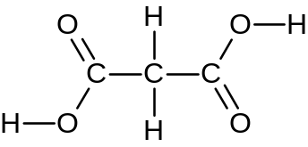 CH₃CH₂CHCH₂ 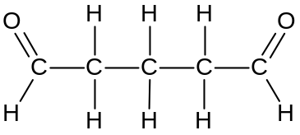
B

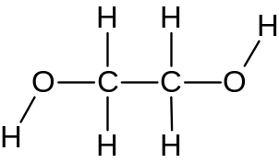 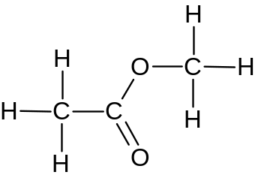 CH₃CH₂Cl
F
D
E

- Using any of the above molecules as monomer(s) draw a structural diagram for a section of a condensation polymer molecule. Your diagram should have two complete repeating units. State the molecule(s) chosen as monomer(s), ie A, B, C, D, E or F. (3 marks)

- Using any of the above molecules as monomer(s) draw a structural diagram for a section of an addition polymer molecule. Your diagram should have three complete repeating units. State the molecule(s) chosen as monomer(s), ie A, B, C, D, E or F. (3 marks)

Section Three: Extended answer 40% (80 Marks)

This section contains seven (7) questions. You must answer all questions. Write your answers in the spaces provided.

Where questions require an explanation and/or description, marks are awarded for the relevant chemical content and also for coherence and clarity of expression.

Final answers to calculations should be expressed to three (3) significant figures and include appropriate units.

Spare pages are included at the end of this booklet. They can be used for planning your responses and/or as additional space if required to continue an answer.
- Planning: If you use the spare pages for planning, indicate this clearly at the top of the page.
- Continuing an answer: If you need to use the space to continue an answer, indicate in the original answer space where the answer is continued, i.e. give the page number. Fill in the number of the question(s) that you are continuing to answer at the top of the page.

Suggested working time: 70 minutes.

Question 37 [11 marks]
Esters are the basis of many naturally occurring odours and are therefore widely used in the creation of artificial flavours. The particular ester shown below is a major component that contributes to the smell of pineapple. A manufacturer wishes to produce this compound as a food additive. The reaction involved is shown:

CH₃OH(aq) + C₃H₇COOH(aq) ⇄ C₃H₇COOCH₃(aq) + H₂O(l)
“pineapple” ester

In a trial procedure to produce this ester a chemist uses 3.40 kg sample of methanol with excess butanoic acid. The methanol used is only 88.5% pure as it contains water which is extremely soluble in methanol and is difficult to remove.

(a) Name the “pineapple" ester. (1 mark)

(b) Explain with the aid of a diagram why water is extremely soluble in methanol. (2 marks)

(c) What maximum mass of ester can the chemist expect? (4 marks)

(d) On completion of the procedure and extraction of the ester the chemist found the process had a yield of 68.5%. What mass of ester was actually produced? (2 marks)

(e) What does the yield of this reaction suggest about the equilibrium constant for the reaction? (2 marks)

Question 38 [14 marks]
The Haber process for the manufacture of ammonia involves a reversible equilibrium reaction that is exothermic with a ΔH of 46 kJ per mole of NH₃ produced. The reaction is operated by passing a mixture of nitrogen gas and hydrogen gas over finely divided iron. The reaction mixture is maintained at a pressure of 300 atm and a temperature of 450 °C.

(a) (i) Use this to information to write a balanced chemical equation for the manufacture of NH₃. (2 marks)

(ii) What is the purpose of the finely divided iron? (2 marks)

(b) Conducting the synthesis of ammonia at a high pressure has several advantages, state two advantages of producing ammonia this way and use your knowledge of chemical principles to support your answer. (6 marks)

Advantage 1:
Explanation based on chemical principles:

Advantage 2:
Explanation based on chemical principles:

(c) Based on chemical principles alone, pressures well above 300 atm would be even more advantageous. Suggest why such higher pressures are not used. (1 mark)

(d) The chosen temperature of 450◦C is said to be something of a compromise. Explain what this means. (3 marks)

Question 39 [11 marks]
A student carried out an experiment with some magnesium and a hydrochloric acid solution. In this experiment, the student added a granule of magnesium with a mass of 0.152 g to a conical flask containing 85.5 mL of 0.0951 mol L⁻¹ hydrochloric acid. This resulted in the formation of hydrogen gas as shown here.
Mg(s) + 2HCl(aq) →MgCl₂(aq) + H₂(g)
(a) What was the pH of the solution in the flask prior to adding the magnesium granule? (2 marks)

(b) Determine the number of moles of magnesium and hydrochloric acid initially present in the flask. (2 mark)

(c) How many moles of hydrogen gas could be expected from this experiment? (2 marks)

(d) Calculate the volume of H₂ gas that would be expected if the gas were collected at 28.0 ºC and 104 kPa. (2 mark)

(e) The student repeated this experiment using a granule of strontium of similar dimensions to the granule of magnesium.

(i) What difference would you expect in reaction rate? (1 mark)

(ii) Explain your answer to (i). (2 marks)

Question 40 [13 marks]
Wines often contain a small amount of sulfur dioxide that is added as a preservative. The amount
of sulfur dioxide added needs to be carefully calculated; too little and the wine goes bad; too much
and the wine tastes of sulphur dioxide.

The sulfur dioxide content of a wine can be tested by titration with an aqueous iodine solution, I₂(aq). The reaction involved is shown here:

SO₂(aq) + I₂(aq) + 2H₂O(l) → SO₄²⁻(aq) + 2I⁻(aq) + 4H⁺(aq)

(a) What species is oxidised in this reaction? Support your answer with an explanation. (2 marks)

Species that has been oxidised
Explanation:

(b) Suggest how the end point of this titration might be observed. You may assume the wine is almost colourless and that the iodine solution is added from the burette. (2 marks)

(c) What problem would you encounter by having the I₂ (aq) solution in the burette? (2 marks)

(d) The sulfur dioxide content of a white wine sample was found by titration with iodine. In this procedure a laboratory technician measured 50.0 mL of white wine and diluted this to
250.0 mL. She then titrated 20.0 mL samples of the diluted wine with 0.00215 mol L⁻¹ aqueous iodine, I₂(aq). On average 16.40 mL of iodine solution was needed for equivalence. Determine the concentration of sulfur dioxide in the original wine sample in mol L⁻¹. (4 marks)

(e) The generally accepted maximum concentration of sulfur dioxide in wine is 0.25 g L⁻¹. Higher concentrations will make the wine taste unpleasant and concentrations less than 0.01 g L⁻¹ are insufficient to preserve the wine. Comment on the effectiveness of the sulfur dioxide in the wine analysed in (d). (3 marks)

Question 41 [9 marks]
Dioxin is a dangerous pollutant that needs to be closely monitored in our food and the environment. The formula of dioxin is C₁₂H₄O₂Cl₄. On combustion, the chlorine in dioxin is completely converted into hydrogen chloride gas. An impure sample of dioxin with a mass of 3.600g was burnt in oxygen. The hydrogen chloride produced was bubbled through 50.00 mL of 1.030 mol L⁻¹ potassium hydroxide solution. The resulting solution was then titrated with a standard solution of 0.500 mol L⁻¹ sulfuric acid and an average titre of 23.65 mL was required. Calculate the percentage, by mass, of dioxin in the impure sample.

Question 42 [13 marks]
The corrosion of iron is a redox process that causes iron and steel structures to decay and become degraded over time. In an investigation into the corrosion process a student placed some iron nails into a variety of different environments and observed the extent of corrosion that occurred. He compared the extent of corrosion by looking for the amount of orange/brown deposit that formed in the test tubes.
iron nail

tap water
iron nail

salty water
iron nail wrapped in zinc strip

tap water

rank
rank
rank

- What is the likely chemical composition or the orange/brown precipitate? (2 marks)

- Rank the three tubes 1 (the most corrosion) to 3 (the least corrosion). Place your ranking in the boxes above. (2 marks)

- Explain how the zinc strip and iron nail used above could be arranged to make an electrochemical cell that would produce an electric current. You can use any of the glassware usually available in a school laboratory. If you are using any other reagents to produce your cell you should note this. Include a labelled diagram of your electrochemical cell and give a detailed description of how it operates. (9 marks)

Question 43 [9 marks]
A 3.210 g sample of an organic compound containing the elements carbon, hydrogen and chlorine only is burnt in air. All of the water produced during the compounds combustion was absorbed by bubbling the gas mixture of combustion products through some pure sulfuric acid. As a result the sulfuric acid increases in mass by 0.6446 g.

- What is the mass of hydrogen in the sample of organic compound? (2 marks)

The remaining products of combustion are then passed through a sodium hydroxide solution, thus absorbing any carbon dioxide present as sodium carbonate. Addition of excess calcium nitrate solution yields a precipitate of calcium carbonate. When washed and dried the resulting calcium carbonate was found to have a mass of 4.810 g.

- Determine the mass of carbon in the sample of organic compound. (3 marks)

- Determine the organic compound's empirical formula. (4 marks)

END OF PAPER
Additional working space

Additional working space

